DEPARTMENT OF MECHANICAL ENGINEERING



**University of Massachusetts Lowell**

COMP.7060 – Directed Research

**Development of a Radar-IMU system for 3D-DIC measurements using remotely paired UAVs**

***Technical Report***

|  |  |  |  |
| --- | --- | --- | --- |
| **Students** |  | | **Supervisors** |
| *M. Sameer Khan* | | (01676411) | *Prof. C. Niezrecki* |
| *Narasimha Prashanth C R* | | (01669930) | *Dr. A. Sabato* |
| *M. Sameer Khan* | | (01654104) |  |

**ABSTRACT**

3D-DIC is a technique used to compare image data mathematically, using the statistical data and was extended from specular surface measurements. This report describes the process of setting up the hardware required for 3D-DIC measurements, calibrating it to get accurate readings and ultimately mounting this setup on two remotely paired UAVs. We use the IMU and Radar to measure the Acceleration, Gyro, and Compass readings - a total of 7 parameters, which is the basis of our experiment. Once the accuracy of the measurements is established, we are ready to connect the sensors to the drones using a mini-computer (in our case a Raspberry Pi 3 Model B). This is the last step in getting our experimental setup ready to perform 3D-DIC measurements with complete accuracy.

**Keywords**: Radar, IMU, Nucleo, Embedded, 3D, UAVs, FMCW Radar, Drones, Drone based 3D-DIC, sensors, data processing, sensor data, 3D capture, Digital Image Correlation, Raspberry pi.

**TABLE OF CONTENTS**

|  |  |
| --- | --- |
| **Abstract** | 3 |
| **Index** | 4 |
| ***1 - Introduction*** | 7 |
| ***2 - Methods***   |  | | --- | | ***2.1 Equipment*** | | ***2.2 Sensors*** | | ***2.3 Procedure*** | | 7   |  | | --- | | 8 | | 8 | | 10 | |
| ***3 Test Case Description*** |  |
| ***4 Analysis of Results*** | 16 |
| ***5 Conclusion*** |  |

**LIST OF FIGURES** (list the different figures together with the page numbers where they are)

Fig. 1 – Caption of figure 1 page xx

Fig. 2 – Caption of figure 1 page xx

…

…

…

Fig. n – Caption of figure n page xx

**LIST OF TABLES** (list the different Table together with the page numbers where they are)

Tab. 1 – Caption of table 1 page xx

Tab. 2 – Caption of table 2 page xx

…

…

…

Tab. n – Caption of table n page xx

**1 - INTRODUCTION**

Digital Image Correlation is a newer technique which uses sensitive optics, to find the deformation, peaks etc. in large deformation problems. However, in our project, we use this technique to capture 3D-DIC so that we can measure and analyze the structure in question. Further, this method is useful for different applications, largely towards very wide and tall structures. 3D-DIC is an offset of specular light analysis, where the specs are arbitrarily done, and statistical data processing is fully utilized to interpretation of data. The data received from this technique needs to be post processed, for us to interpret it. In this project, we utilize this technique to implement drones enabled with cameras or IMU and Radar, in swarms of 2 or more, to stereotypically capture the data and use the 3D-DIC to process it, and analyze the results.

The objective of this project involves the use of a RADAR-IMU system for 3D-DIC measurements by using two remotely paired drones. The aim of this project is twofold - first, getting the RADAR and IMU calibrated and working synchronously and second, mounting them on two separate drones that are remotely paired. Through our project we found that calibration itself was a strenuous process. The distance between the drones and any other objects in the environment is measured using the radar, which provides with a multi-tuple value. This set of values is then processed through MATLAB by plotting Fast Fourier Transforms and getting the peak values from the graphs generated. Similarly, for the IMU, we use the required libraries and software to generate real-time data. The process involved in this is that we need to move the IMU slowly under small increments. We capture each data element for all the angles one by one and generate corresponding graphs to calibrate the IMUs accuracy.

After verifying the results through the graphical data carefully, we are ready to assume that the sensors are now accurate. Next, we mount them on a drone and attempt to perform the same measurements, so the two drones can work synchronously without any problems. This report describes the entire process, equipment involved, techniques used and further, analyses the result and determines the accuracy of the calibration.

**2 - METHODS**

*2.1 List of equipment used:*

• ***Hardware***:

- Nucleo STM32F411RE development board

- InvenSense carrier board

- ICM20948

- FMCW Radar – RS3400W

- Voltage Regulator

• ***Software***:

- IAR Embedded Workbench 7.70

- Anaconda (for Python 2.7)

- Embedded Motion Driver (eMD) ICM-20948 v1.0 for Nucleo Board

- MotionLink v2.0.9

- MATLAB for computing Fast Fourier Transform for Radar

- TeraTerm for UART interface with Radar

*2.2 The Sensors*

First, for receiving data from surroundings we have various sensors placed strategically, in the system we are implementing, as we require different type of sensor measurements. The first sensor in our system is the Inertial Measurement Unit (IMU). Many Inertial Navigation Systems (INSs) including ours use an IMU to measure acceleration and direction of motion (through gyroscope). The IMU we are using for this project is the InvenSense ICM20948. The Embedded Motion Driver is an embedded software stack of the sensor driver layer that easily configures and leverages many of the features of InvenSense motion tracking solutions. The ICM-20948 is the world’s lowest power 9-axis MotionTracking device that is ideally suited for Smartphones, Tablets, Wearable Sensors, and IoT applications. It uses only 1/3rd the power of existing 9-axis devices and has 3-axis gyroscope, 3-axis accelerometer, 3-axis compass, and a Digital Motion Processor (DMPTM) in a 3x3x1mm (24-pin QFN) package.

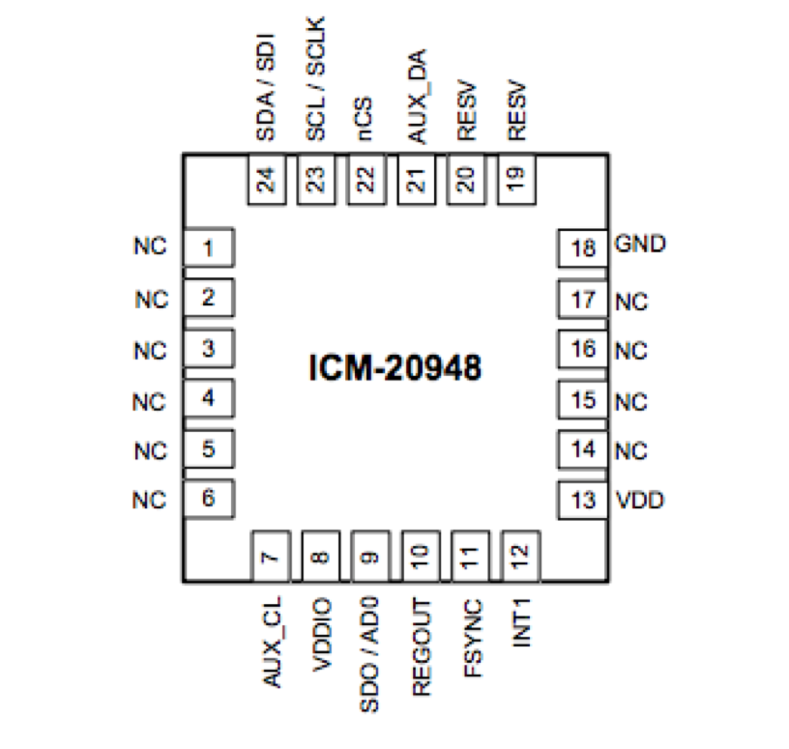

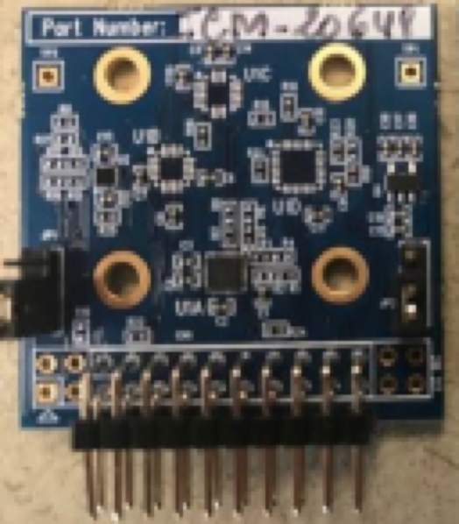

**Fig:** Pin out Diagram and actual image for ICM-20948 3 mm x 3 mm x 1 mm QFN

To use the ICM20948, we connect it to an STM ARM Cortex M4 board, in our case, a STM32 Nucleo-64 development board with STM32F411RE MCU. This interface provides a very reliable access to the component, through MotionLink software or C/C++ using their Workbench. This whole setup includes an interface for the IMU itself, and a NUCLEO board, all powered individually, using USB Cables. No external power supply is required. The setup is easy to achieve and work with, as show in the figure below.

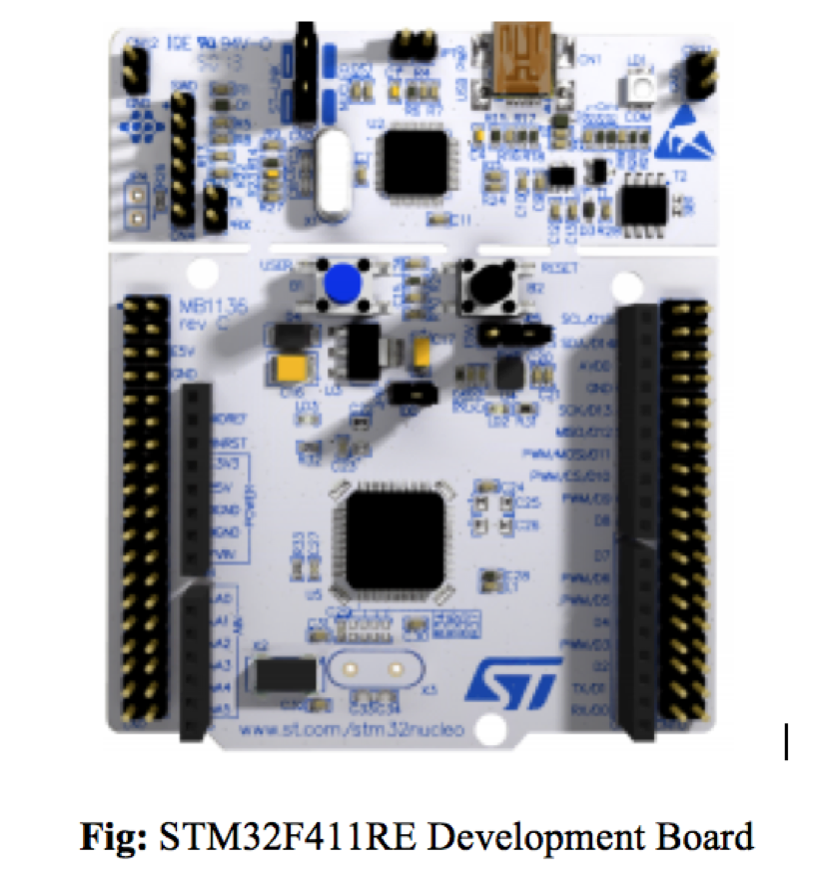

The second sensor in this system is the FMCW Radar – RS3400W. Frequency Modulated Continuous Wave radar differs from pulsed radar in that an electromagnetic signal is continuously transmitted. FMCW radars in the GHz spectrum provide excellent distance measurement performance in applications where high accuracy, repeatability and reliability are needed. Because of the short wavelength, resolutions on the order of 2 cm can be achieved over distances of 20-30 meters.

Due to the non-contact nature of the measurement system, and due to the nature of the microwave, FMCW radar operating in the GHz range also exhibit excellent resistance to dust, steam, heat, etc. This allows for use in demanding conditions and hence we decided to use it for our project. The RS3400W/04 is a W-band FMCW radar front end featuring synthesized frequency sweeps. A fast sweep mode enables complete sweeps below 1ms. The system provides one Tx/Rx with a WR12 waveguide interface suitable for attaching compact high directivity antennas.

The setup involves the usage of an external power supply of 12V to power the radar system. Measurements of the radar are received on the terminal window of the attached computer. Connections are through USB on the PC and a visual cable(VGA) on the interfacing board. The radar component is installed on the tightly coupled interface board. Commands can be sent, and data can be received through the USB connection to PC and a U ART Term. The data received must be processed to be able to calibrate the device. The setup is shown below.

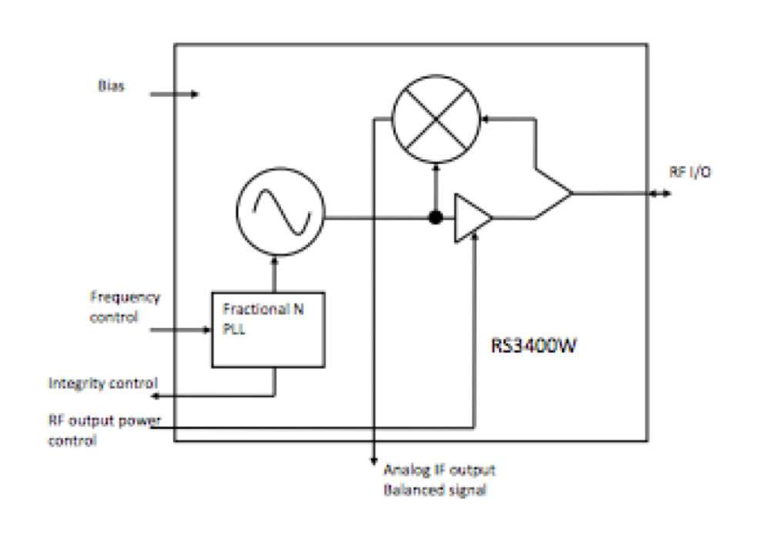

**<- Fig:** Block diagram for RS3400W/04

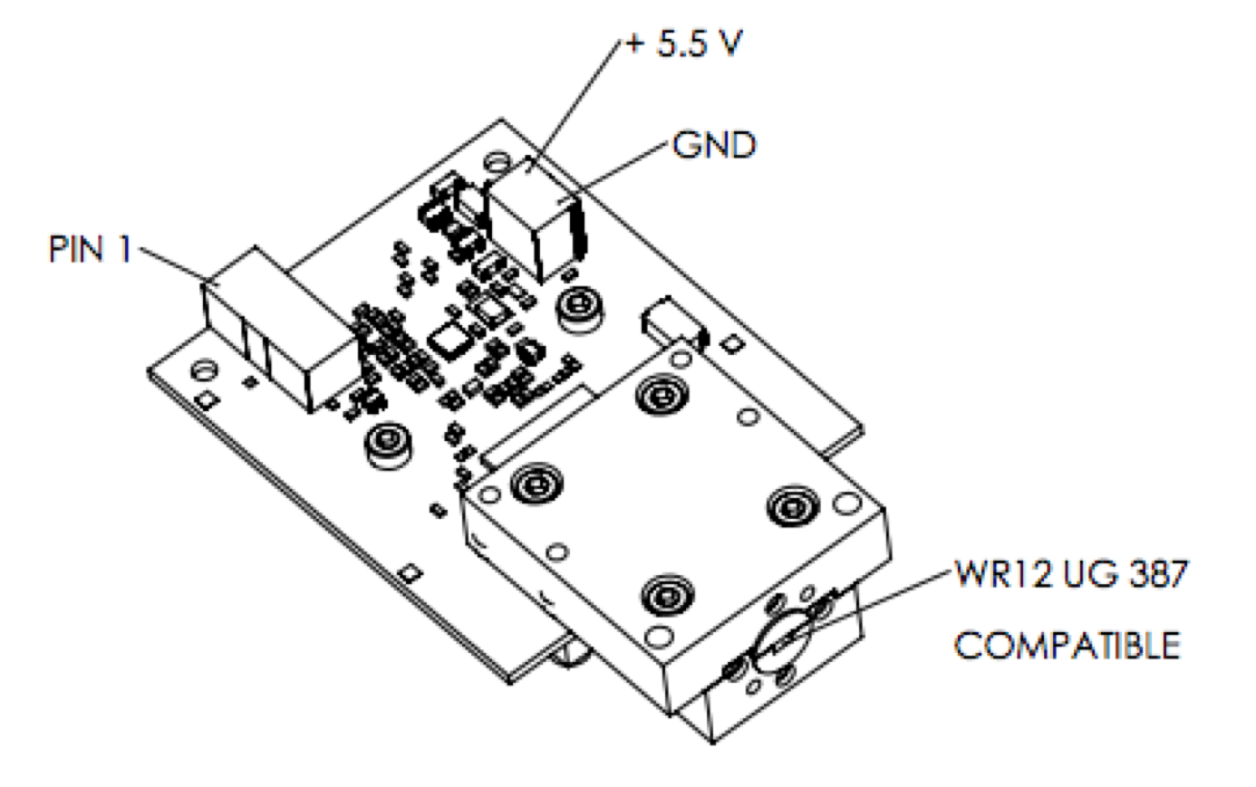

**Fig:** RS3400W/04 Interface **->**

*2.3 Procedure*

IMU MotionLink measurements:

The Embedded Motion Driver (eMD) is designed as a solution that can be easily ported to most MCUs. The eMD 20x48 release package contains the example project for STM ARM Cortex M4 Core. Using IAR Workbench, we compile the files needed to flash the IMU for setting it up to get the 9-axis measurements. We then go into MotionLink and configure the correct connection port before starting the measurement log. MotionLink provides us with graphical plots to visualize the sensor data as well as read/write to hardware registers. We log the data to external files, 72 measurements – 1 for every 5 degrees in a 360-degree motion of the setup; each of the 72 measurements containing the readings for every axis of the 9-axes. We take these 72 measurements in 3 orientations – along the x-axis, y-axis and z-axis, tilting the setup as required. Once we get the measurements for every orientation, we need to calibrate them. We use the pandas library in Python to compute the mean and total deviation. We can then plot the graphs for each of the axis at every degree using the matplotlib library in Python. A snippet of the python code used can be seen below.

The results for the graph plots can be seen in the figure below.

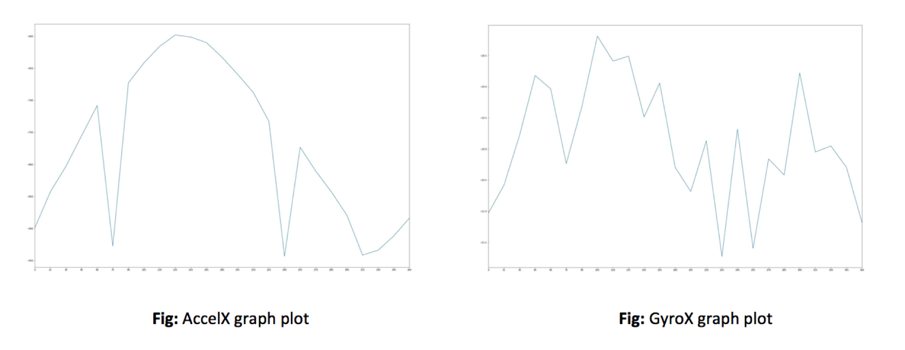

Radar Measurements:

However, for the RADAR, the process is slightly different. The first thing we had to decide when using this sensor was to determine the choice of antenna. The antenna choice has a significant impact on the range and field of view of the final sensing system. For our application, we are using a horn antenna since this type of antenna is best suited for outdoor use. The communicate with the development board connected to the RADAR, we need to use a terminal emulation program such as PuTTY. However, since we must take many readings, we cannot rely on inputting commands every time and, so we wrote a python program using the ***‘serial’*** library that does this work for us. A little snippet of the code from the program is given below.

The initial configuration for the RADAR is as follows:

• Bits per second: 115200

• Data bits: 8

• Parity: None

• Stop bits: 1

• Flow control: None

Some of the command that can be sent to the system are:

- **INIT:** To initialize the system

- **SWEEP: MEASURE ON**

- **SWEEP: NUMBERS <X>**

- **TRIG: ARM**

- **TRIG:DATA?**

The last command TRIG:DATA? gives us the measurements that we need based on the parameters that we have set above. We save the measurement data to text/csv file, so we can use it later to plot the Fast Fourier Transforms (FFT).

For plotting the FFTs we first use the pandas library in Python to order the data received as output and then use the scipy library to plot the graphs.

**3 - TEST CASES STUDIED / TESTING PERFORMED**

Since all we get from the devices is raw data, we need to do a lot of calibrating to get accurately measure each sensor.

**3.1 Testing for ICM-20948:**

The ICM 20948 is a 9-axes device. It contains 3-axes Gyroscope, 3-axes Accelerometer and 3-axes Compass. To calibrate the ICM 20948, the device is fixed to a dial with marked readings from 0 degrees to 360 degrees like the picture below.

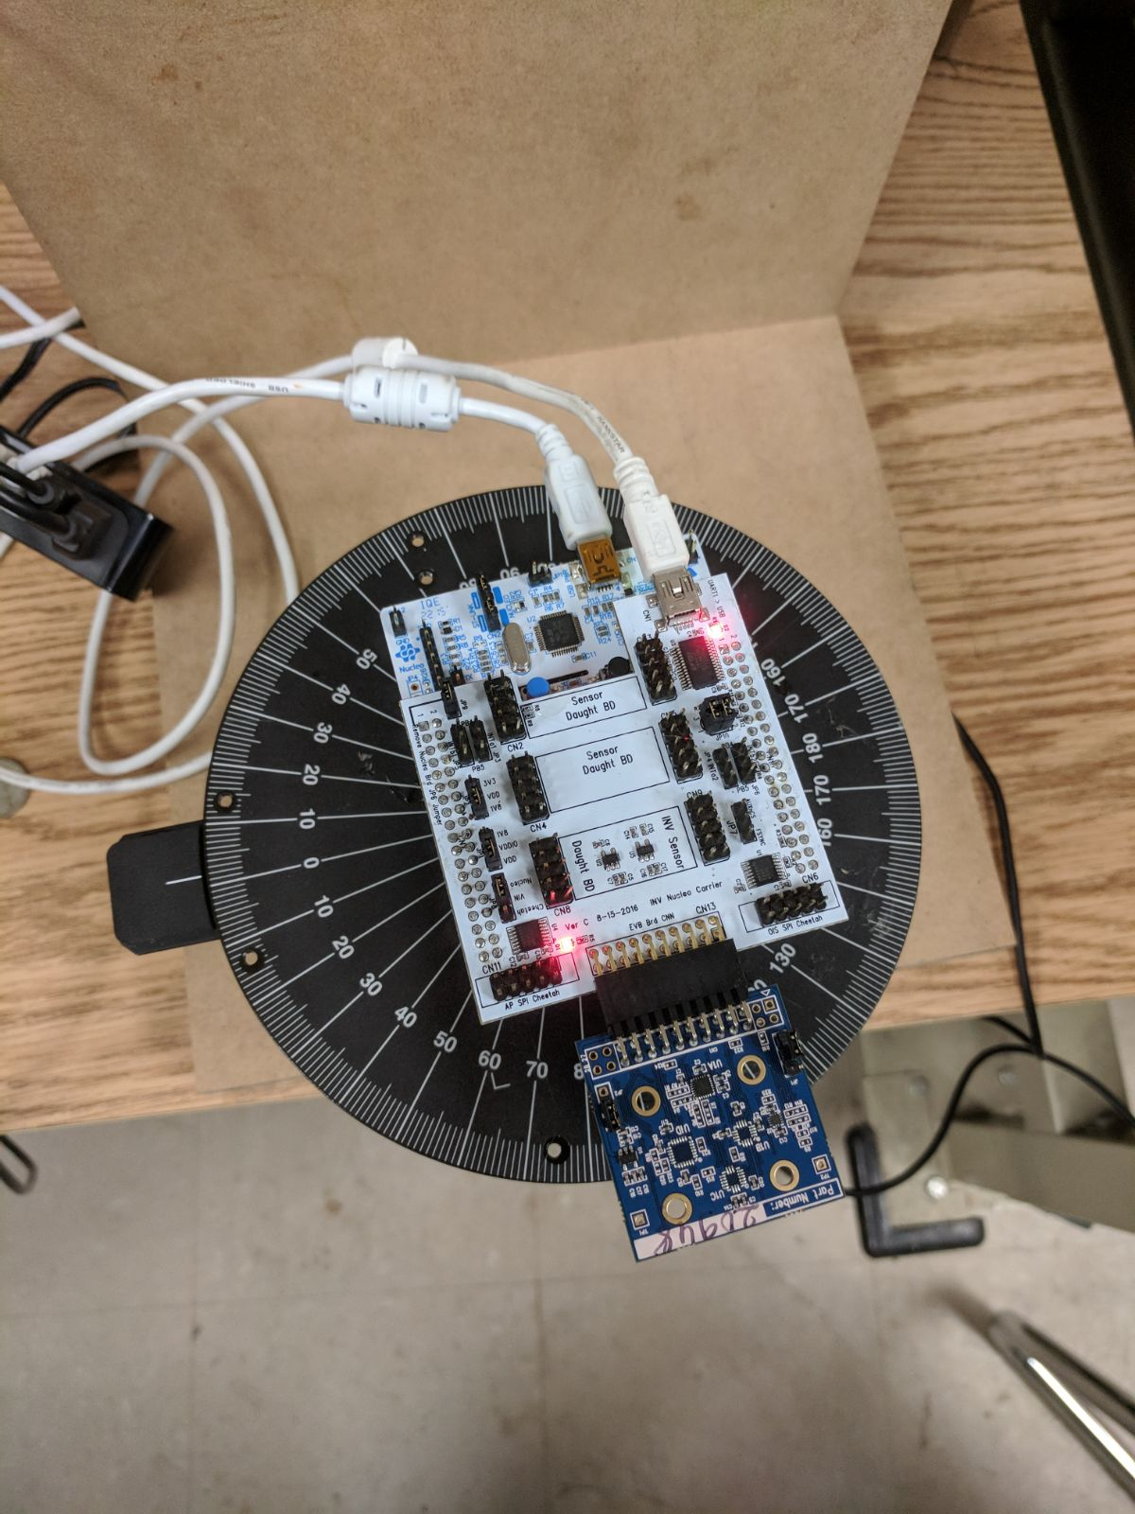

To make sure we do not affect the readings in any way, we have fixed the device to the board using hot glue and placed the entire setup on a heavy object which will prevent small fluctuations.

We have taken readings for all the three sensors (Gyroscope, Accelerometer and Compass) for every 5 degrees. The readings taken are the average of readings for one minute. In this process, we assume the temperature is constant at the room temperature.

This process is continued in two other orientations to accurately calibrate Gyroscope, Accelerometer and Compass.

**3.2 Testing for 77GHz FMCW Radar:**

The radar used is 77GHz radar manufactured by Sivers IMA. To accurately measure Radar’s readings, we have taken the average of readings for 30 seconds. We have used two other means to calibrate the measurements from Radar. We used a tape measure and digital measure.

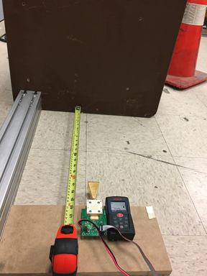 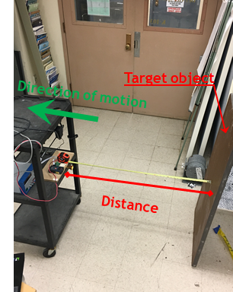

The radar is calibrated using the above testing method.

**4 – ANALYSIS OF THE RESULTS**

After performing the experiment, we have generated a set of tables to capture the analysis. We have measured it against the physical systems for their dimensions.

**4.1 IMU Results**

The IMU was measured against a smartphone, equipped with the required sensors, Accelerometer and Gyroscope. These sensors have a very low margin of error on a commercially configured smartphone. Upon verification with the mobile device, we were able to witness the error to be very low, in the order of less than 2 degrees. The following tables allow us to visualize the results.

This is a very low value, however due to difficulty conducting this test, we believe that the error might be due to human error, more than anything else. Hence, we believe the system is very accurate. The sensors on the phone and IMU are subject to interference, from electrostatic charges, electromagnetic waves of high intensity and other such attenuation or deflection of values.

These cases can be studied in further detail. However, we believe the noise from the environment is marginal and can be ignored. 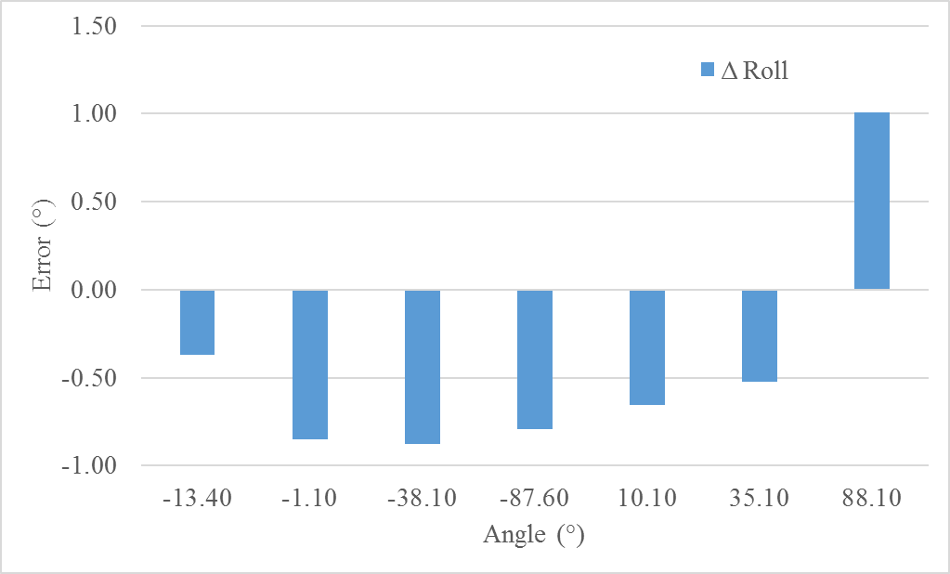

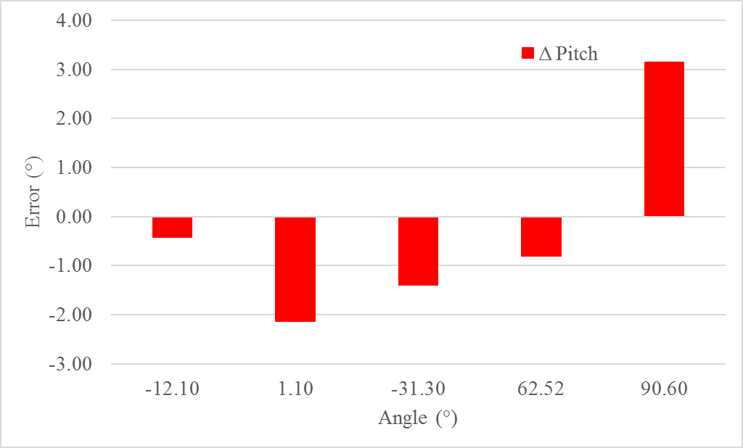

|  |  |  |  |  |  |
| --- | --- | --- | --- | --- | --- |
| Roll angle | | | | | |
| Cellphone (°) | | **IMU (°)** | | **Cellphone - IMU (°)** | |
| -13.40 | | *-13.03* | | *-0.37* | |
| -1.10 | | *-0.25* | | *-0.85* | |
| -38.10 | | *-37.22* | | *-0.88* | |
| -87.60 | | *-86.81* | | *-0.79* | |
| 10.10 | | *10.76* | | *-0.66* | |
| 35.10 | | *35.62* | | *-0.52* | |
| 88.10 | | *87.09* | | *1.01* | |
|  | | **Average** | | **0.72** | |
| Pitch angle | | | | |
| Cellphone (°) | **IMU (°)** | | **Cellphone - IMU (°)** | |
| -12.10 | -11.68 | | -0.42 | |
| 1.10 | 3.24 | | -2.14 | |
| -31.30 | -29.91 | | -1.39 | |
| 62.52 | 63.32 | | -0.80 | |
| 90.60 | 87.45 | | 3.15 | |
|  | **Average** | | **1.58** | |

**4.2 RADAR Results**

The RADAR was targeted at a distant solid metal wall, and was moved away slowly in increments of 0.5m. This test was performed by taking multiple readings at each step, which allowed for significant data average and statistical parameters.

|  |  |  |  |  |  |
| --- | --- | --- | --- | --- | --- |
| Tape | | Laser | | Radar | |
| x (10-3m) | **σ (10-3m)** | **x (10-3m)** | **σ (10-3m)** | **x (-)** | **σ ( - )** |
| 500.0000 | **0.0000** | **495.8571** | **0.3499** | **76.7275** | **0.4517** |
| 1000.0000 | **0.0000** | **997.5714** | **0.7284** | **76.1912** | **0.0003** |
| 1500.0000 | **0.0000** | **1498.0000** | **0.9258** | **75.9374** | **0.0006** |
| 2000.0000 | **0.0000** | **1996.4286** | **0.7284** | **75.6866** | **0.0005** |
| 2500.0000 | **0.0000** | **2496.1429** | **0.3499** | **75.4353** | **0.0019** |
| 3000.0000 | **0.0000** | **2996.6667** | **0.4714** | **75.1702** | **0.0013** |
| 3067.1429 | **0.3499** | **3066.8571** | **0.3499** | **75.1349** | **0.0003** |
| 3500.0000 | **0.0000** | **3499.0000** | **1.0690** | **74.9139** | **0.0007** |
| 4000.0000 | **0.0000** | **3997.4286** | **0.4949** | **74.6596** | **0.0006** |
| 5047.0000 | **0.0000** | **5045.4286** | **0.4949** | **74.1265** | **0.0005** |
| 7503.0000 | **0.0000** | **7497.8571** | **1.3553** | **72.8619** | **0.0005** |

Upon receiving these values, we were able to infer that the RADAR has an error margin of less than 4x10-3m. This is not a very large error. RADAR has been tested against a tape measure and a digital measure. The chart above helps to visualize the data, which we have converted to (m) later. By capturing these values, we interpolated the values to derive an equation. The accuracy of this equation is around 99%. The following graph helps to explain this.

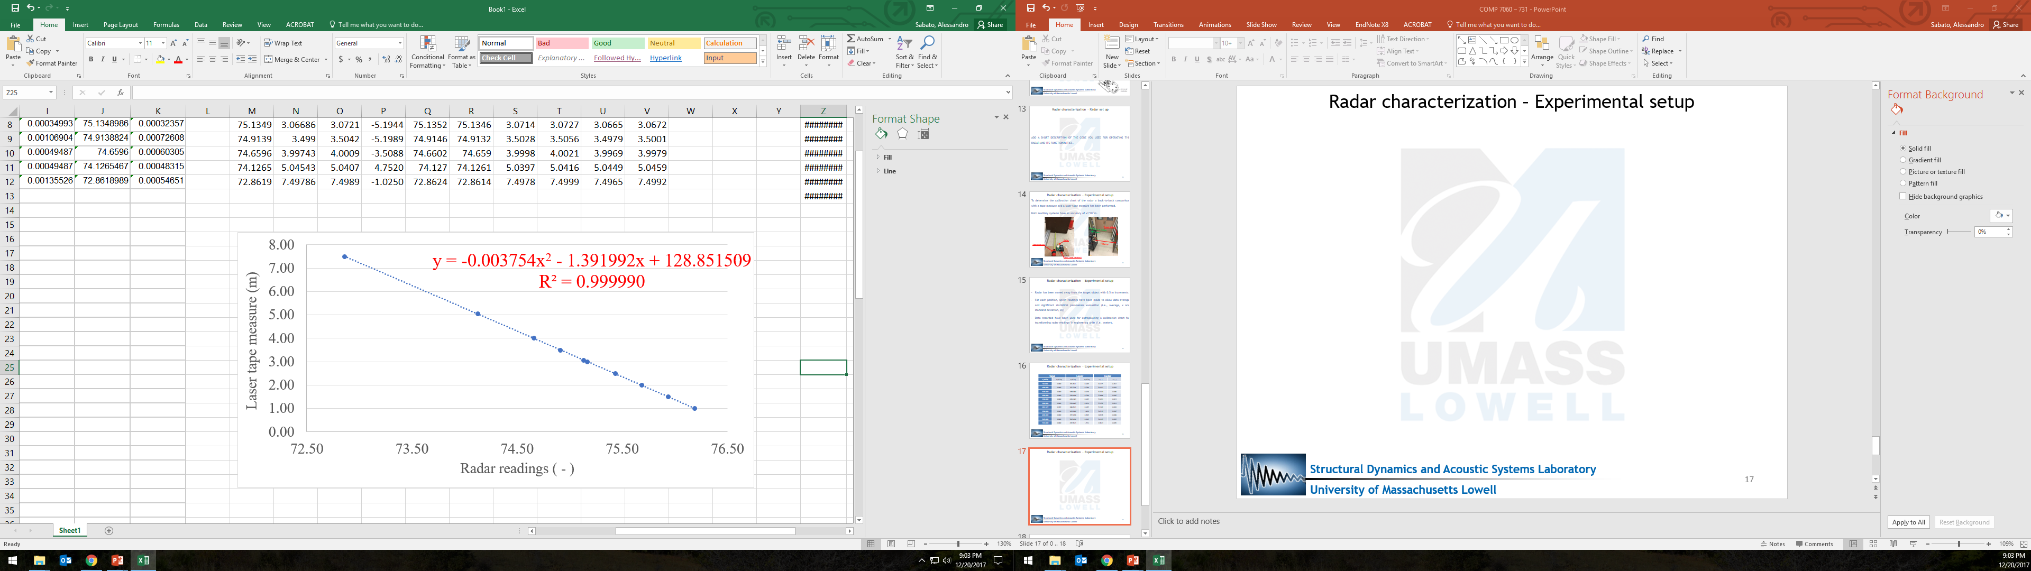

The RADAR provides readings in a raw number format, which needs processing. After processing, we receive the reading in meters. This has been plotted below, which shows that the error in meters is less than 4mm.

|  |  |  |  |  |
| --- | --- | --- | --- | --- |
| **Tape** | **Laser** | **Radar** | **Radar - Tape** | **Radar - Laser** |
| **(10-3m)** | **(10-3m)** | **(10-3m)** | **(10-3m)** | **(10-3m)** |
| 1000.000 | 997.571 | 1001.624 | 1.624 | 4.053 |
| 1500.000 | 1498.000 | 1499.803 | -0.197 | 1.803 |
| 2000.000 | 1996.429 | 1991.792 | -8.208 | -4.636 |
| 2500.000 | 2496.143 | 2484.139 | -15.861 | -12.004 |
| 3000.000 | 2996.667 | 3002.909 | 2.909 | 6.242 |
| 3067.143 | 3066.857 | 3072.052 | 4.909 | 5.194 |
| 3500.000 | 3499.000 | 3504.199 | 4.199 | 5.199 |
| 4000.000 | 3997.429 | 4000.937 | 0.937 | 3.509 |
| 5047.000 | 5045.429 | 5040.677 | -6.323 | -4.752 |
| 7503.000 | 7497.857 | 7498.882 | -4.118 | 1.025 |
| Average Error (10-3m) |  |  | 4.928 | 4.842 |

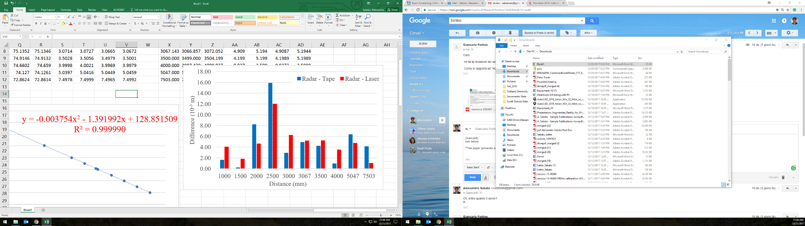

Average error is on the order of 4*10-3 m, comparable with the minimum theoretical value of 2*10-3 m. Another chart explains the maximum probability of error over a range of 0.5m to 8m.

**5 – CONCLUSIONS**

**/\***

**This section may be just the summary or just the conclusions or combinations thereof. This depends on the paper and the end goal of the paper. However, this section must answer questions that were posed in the introduction.**

**The recommendations help the reader to determine what, if anything, should be done in the future to improve on the procedures or methods used.**

**In the conclusion you should show the overall significance of what has been covered. You may want to remind the reader of the most important points that have been made in the report or highlight what you consider to be the most central issues or findings. However, no new material should be introduced in the conclusion.**

**\*/**

The goal of this report and the directed study associated with it was to develop a Radar-IMU system for 3D-DIC measurements using remotely paired UAVs. The most important part of the system was to have absolutely accurate readings and measurements and so most of our work went into calibrating the IMU and RADAR system. This process was critical and worth the effort as now the system is recording measurements in our dimensions. Upon verification with other instruments, we can say that the system is very accurate. If the system succeeds in higher scale applications, or experiments, then it can be recommended for industry production. Further experimentation is required and is in the cards.

We used some simple approaches for calibration and wrote programs in Python for both the IMU and RADAR to automate the measurement process. The process for this has been explained in Section ____ and the subsequent test cases are listed in Section ____.

Future work will be devoted to __________.

**REFERENCES**

Your bibliography should list, in the order they appear in the report, all published sources referred to in your work. There are assorted styles of using references and bibliographies. You can pick one and be consistent through all this section.

**APPENDIX**

Under this heading you should include all the supporting information you have used that is not published. This might include extra tables, graphs, users guide you develop, computer codes you created, electrical circuit design, etc. Refer to the appendices in the body of your report (e.g., the step-by-step procedure for turning the IMU on and perform a measurement has been reported in the attached Appendix N).